**Business Model & Services**

1. **Core Services:**
   * **Car Rental:** What are the available rental options? (Hourly, daily, long-term?) ATM it’s not a service offered. In next future we will offer but we will manage it through a cars booking platform
   * **Parts Selling:**
     + What types of parts will be sold? ATM it’s not a service active. We need to do some few agreements with parts distributors
     + Will this be integrated as an eCommerce platform? yes
   * **Vehicle Repair:**
     + How will the scheduling system work? Users can reserve an available slot by indicating the type of work to be performed. When working process starting, users can check the status accordingly with date of pick up
     + Will the payment process be managed entirely within the system? It will be useful if invoice and payment will be in the platform but we need to check how they working. Otherwise we will use the already existing invoice platform
2. **Primary Business Model:**
   * What is the core revenue-generating model? (Rentals, sales, repairs, subscription services?) atm the most important is repairs
   * Are there any additional revenue streams? Not atm. Next revenue from ecommerce platform and rental activity
3. **Target Audience & User Data:**
   * Who are the primary end users? (Individual customers, corporate clients, fleet owners, etc.) Individual customers are the most profitable source. Corporate and fleet company are more aggressive with their own price list for repair
   * What customer data needs to be collected and stored? (Personal details, vehicle details, service history, payment information?) personal details, vehicle details (model, plate, VIN, year, km, insurance ) service history. Payment not needed, we will manage with other platform. Maybe in the future we will think about

**Branch & Location Management**

1. **Branch Operations:**
   * Will the system support multiple branches? Yes. Our goal is to have multiple branches
   * How will branch locations be managed? Super admin has full control of all data
   * Should customers be able to select their preferred branch for services? Yes. I suppose they select by location and feedback

**Admin & User Roles**

1. **Role Management:**
   * Will the admin role be centralized or branch-specific? We need a super admin with full control over all branches and admin + lower level for branches
   * What level of access will branch managers have versus overall system administrators? They can only view their branch dashboard
   * Are there different levels of employee access (e.g., mechanics, sales staff, customer support)? Yes. Every branches can open lower and different account

**Other Questions:**

1. In this page <https://www.maestridellagrandine.com/carrozzeria/>   
   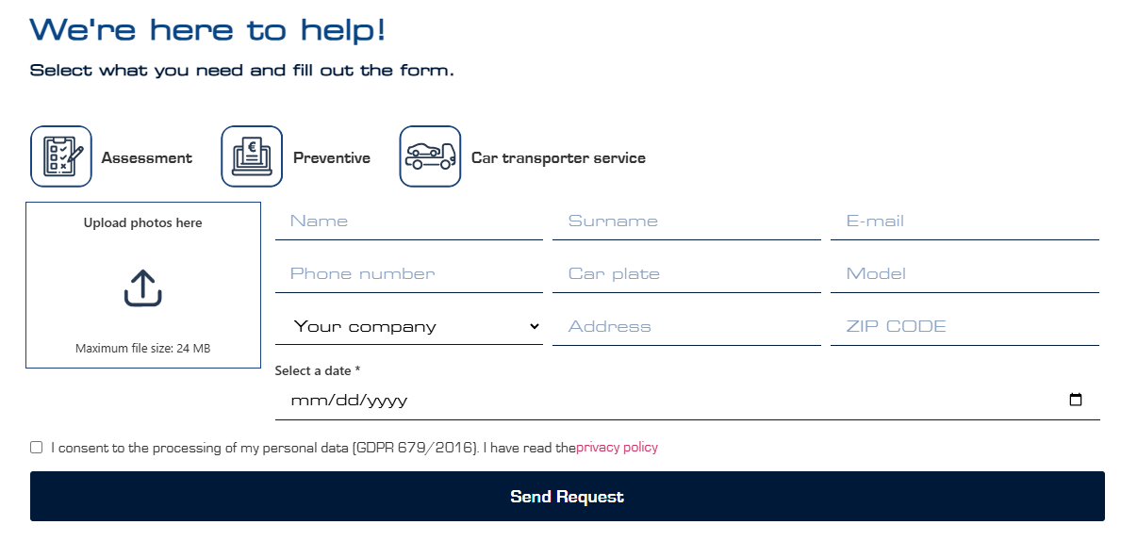

This section is for which purpose? Can u discuss about this section a bit like whats use case scenario.

We don’t need this step. When a user book an appointment, our backoffice will contact him by mail or whatsapp asking insurance company and car details

1. <https://www.maestridellagrandine.com/noleggio/> in this page r we renting cars? For this filling up this form? Not useful for us. We only show in homepage that we offer free car replacement during process repairing car

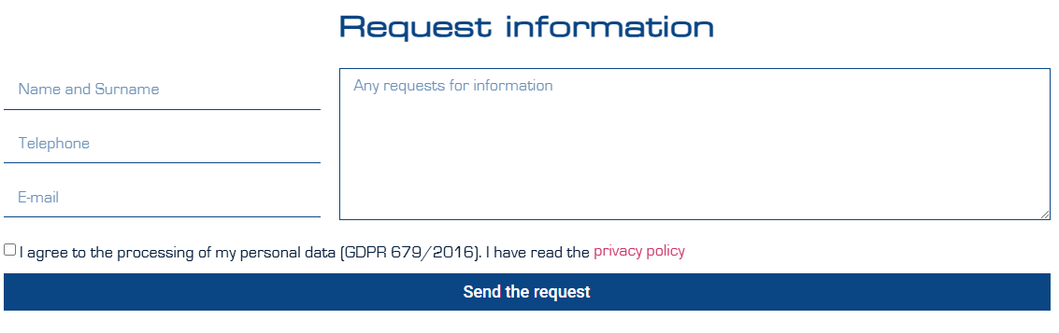

1. When I click on design then it took me to <https://maestridesign.com/>   
   did not understand the use of this page. Not useful for us. I don’t understand because it’s not in line with motorservice business
2. When I click on real-estate getting this - <https://www.maestridellagrandine.com/immobiliare/>   
   not getting any relation of real state to this project, can u explain this. Not useful for us. I don’t understand because it’s not in line with motorservice business

